Early High School ACT Aspire Science Practice Test

Block text for Qs #1 - 8

A scientist wants to measure the amount of a dangerous gas, sulfur dioxide (SO₂), in the air. She measures it in units of concentration, which is the amount of a substance in a set amount of air. The scientist has a sensor that measures concentrations of SO₂ by the turning of a dial, which is shown on the front of the sensor.

Five gases with various SO₂ concentrations were chosen to test the sensor. All of the concentrations are measured in ppb, which stands for parts per billion; 1 ppb means 1 out of every million molecules in the air is SO₂.

Table 1
Gas | SO₂ Concentration
A | 0
B | 50 ppb
C | 100 ppb
D | 150 ppb
E | 200 ppb

Experiment 1
The scientist pumps all 5 gases (A-E) into the sensor box, and records the sensor reading for each gas. The results are plotted in the graph below.

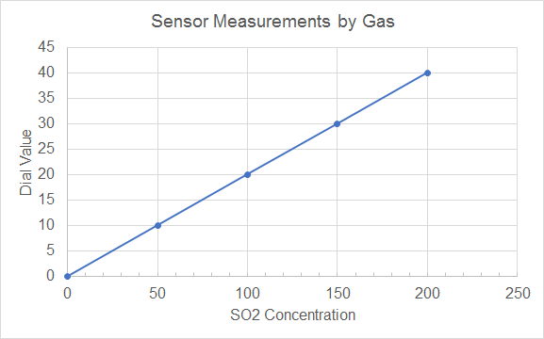
Figure 1: Sensor Measurements by different gases, A-E.

The scientist also brings the sensor to 5 different locations to measure SO₂ concentrations. The sensor readings for each location are shown in the table below:

Table 2
Location | Sensor Readings
House | 3 ppb
Forest | 12 ppb
Bus | 15 ppb
Coal plant | 24 ppb
Volcano | 35 ppb

- Based on Experiments 1 and 2, which of these is closest to the SO₂ concentration on the bus?
- 150 ppb
- 75 ppb
- 15 ppb
- 5 ppb

Answer: B
Table 2 shows that the sensor reading on the bus was 15. From Figure 1, we can see that a sensor reading of 15 corresponds to an SO₂ concentration of 75. B is the correct answer.

DOK 2, IOD

2. If SO₂ is a dangerous gas, which place would be the safest?
- House
- Forest
- Coal Plant
- Volcano

Answer: A
Because SO₂ is dangerous, the safest place would have the lowest SO₂ concentrations. From Table 2, we can see that the house has the lowest SO₂ readings.

DOK 1, IOD

3. A student believes that gas C contains a higher concentration of SO₂ than the volcano. Explain why this student is incorrect.
Constructed Response

2 points: The student explains that sensor reading of the air from the volcano is equal to ~175 ppb (any answer within the range 160 - 190 will be accepted), while gas C corresponds to 100 ppb.
1 points: The student explains EITHER that the sensor reading of the air from the volcano is equal to ~175 ppb (any answer within the range 160 - 190 will be accepted), OR that gas C corresponds to 100 pbb.
0 points: The student’s answer is not relevant.

DOK 3, EMI

4. Further experiments find that the sensor reading for each experiment varies based upon many factors, including wind. These experiments find that any sensor reading can vary both above and below the value recorded in Experiment 2 by 4. Which two sensors could possibly record the same value in future experiments, according to this variation?
- House and Forest
- Forest and Coal Plant
- Bus and Volcano
- Bus and Forest

Answer: D
Each sensor has a range of values it can take, which varies from the values recorded in Experiment 2 by -4 or +4. Thus, the range of values each location have is:
House: 0-7
Forest: 8-16
Bus: 11-19
Coal plant: 20-28
Volcano: 31-39
In order for two locations to show the same value in the future, their possible range of values must overlap. The only two locations whose possible values overlap are the forest and bus, as the numbers 11 - 16 are present in both ranges. Option D is the correct answer.

DOK 3, EMI

5. The government has set standards for the risk level associated with different concentrations of SO₂:

Level of Risk | Concentrations
Safe | 0 - 50 ppb
Dangerous | 50 - 150 ppb
Extremely Dangerous | 150 - 250 ppb

Constructed Response:
Let the 5 locations: house, forest, bus, coal plant, volcano, be sorted between the three areas: safe, dangerous, extremely dangerous.

Correct response:
Safe: house
Dangerous: forest, bus, coal plant
Extremely Dangerous: volcano

2 points: All 5 locations are placed correctly
1 point: 3-4 locations are placed correctly.
0 points: 0-2 locations are placed correctly.

DOK 2 or 3, EMI

6. In a new experiment, the students test the concentrations of SO₂ at a school, and find that the SO₂ concentrations are 115 ppb. Which location contains the closest SO₂ concentration to the school?
- House
- Bus
- Coal Plant
- Volcano

Answer: C
By Figure 1, 115 ppb is equivalent to a sensor reading of 22 or 23. The location with the sensor reading closest to this is the coal plant, as shown in Table 2.

DOK 2, IOD

7. According to government standards, the SO₂ concentrations at the volcano are described as ‘Extremely Dangerous.’ How much lower would the SO₂ concentrations at the volcano have to be to be classified as safe, if safe is defined as 0-50 ppb?
- 225 ppb
- 200 ppb
- 125 ppb
- 50 ppb

Answer: C
The SO₂ concentration at the volcano is 175 ppb, and to be classified as safe, the concentration would need to drop to 50 ppb. The difference between these is 175 - 50 ppb = 125 ppb. Option C is correct.

DOK 2, IOD

8. The dial in the SO₂ sensor has a limit, and can only up to 55. What is the highest SO₂ concentration that the sensor can measure?
- 175 ppb
- 250 ppb
- 500 ppb
- There is no limit

Answer: B
For every increase in the dial of 10 units, the SO₂ concentration increases by 50 ppb. Thus, if the dial were to turn 10 beyond 40, to reach 50, then the SO₂ concentration should be 50 ppb higher than 40, which is 250 ppb. Option B is correct.

DOK 2, IOD

Block Text for Qs # 9 - 16

Students used bacterial culture to grow colonies of the bacteria prochlorococcus. The bacterial culture consisted of a large glass bottle containing the bacteria, as well as nutrients, which are necessary for the bacteria to grow.

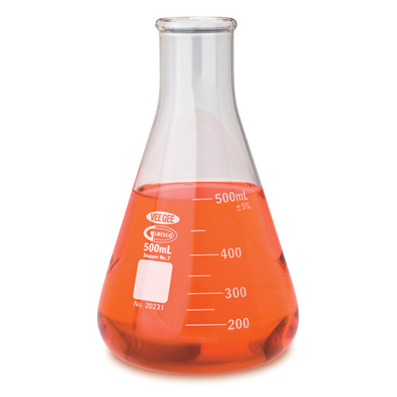

Experiment 1

The students added bacteria and nutrients to empty glass bottles in different parts of the classroom to see how the bacteria would grow. They added 1g of bacteria to each bottle and 10g of nutrients. They placed the bottles in three places: a dark closet, the window of the classroom with partial sunlight, and outside in full sunlight. After 3 days, they measured the amount of bacteria in each bottle. Shown below is a table of the amount of bacteria from each bottle.

Table 1: Bacteria in different locations
Location | Amount of bacteria (grams)
Closet | 0g
Window | 6g
Outside | 14g

Experiment 2

The students also tested adding different amounts of nutrients to bottles. They filled three bottles with different amounts of nutrients: 0g, 5g, 20g. They also added 1g of bacteria in each bottle and then placed all of the bottles outside.

Table 2: Amount of nutrients in each bottle
Bottle | Amount of nutrients
A | 0g
B | 5g
C | 20g

The students measured the amount of bacteria present in each bottle after 3 days and plotted the relationship between amount of bacteria and nutrients.

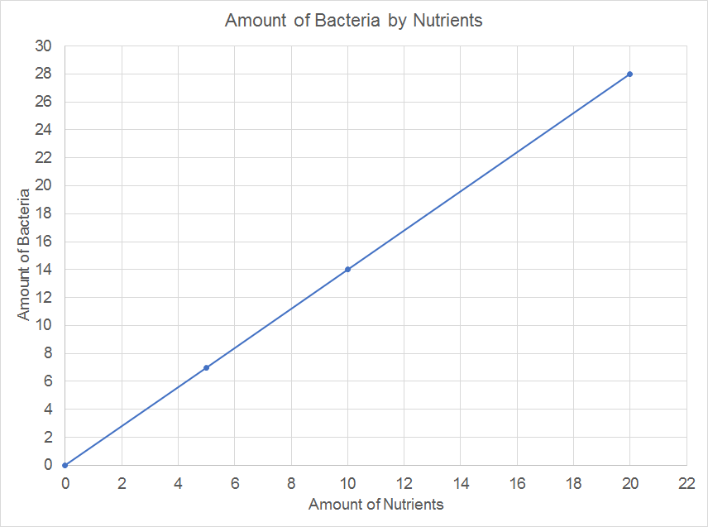
Figure 2: Bacteria by nutrients added.

9. How much bacteria did the students measure in bottle B after experiment 2?
- 3g
- 5g
- 7g
- 14g

Answer: C
The students added 5g of nutrients to bottle B in experiment 2. From Figure 2, this corresponds to 7g of bacteria. Option C is correct.

DOK 2, IOD

10. How many total grams of nutrients were used in Experiment 2?
- 0g
- 14g
- 20g
- 25g

Answer: D
In Experiment 2, nutrients were added to three bottles, A, B, and C. To find the total amount of nutrients used, we should add together the amount of nutrients added to each bottle: 0g + 5g + 20g = 25g. Option D is correct.

DOK 2, SI

11. A student theorizes that the amount of sunlight the Prochlorococcus bacteria receive affects how much they can grow. Which amount of sunlight resulted in the most growth in the bacteria?
- Growth was the same in all lighting conditions.
- Complete darkness
- Partial sunlight; shaded during part of the day
- Complete sunlight; no shade

Answer: D

In Experiment 1, the students placed the bottles of bacterial culture in three different lighting conditions: darkness (in the closet), partial sunlight (the classroom window), and full sunlight (outdoors). From this experiment, we can see the bottle placed outdoors had the most bacteria present after 3 days, and can conclude that complete sunlight with no shade resulted in the most growth.

DOK 2, IOD

12. The students set up a third experiment, Experiment 3, and add 1g of bacteria and 10g of nutrients to Bottles M and N. The students place Bottle M in the window and leave it for 3 days. The students place Bottle N outside for two days, and move it to the window for a third day. How would the amounts of bacteria compare between Bottles M and N?
- More bacteria in Bottle M
- More bacteria in Bottle N
- The same amount of bacteria in each bottle
- We cannot tell based upon this information.

Answer: B
Because the amount of sunlight impacts the growth of Prochlorococcus, the bottle that has received the most sunlight will grow the most. In this case, Bottle N receives full sunlight for 2 days and partial sunlight for 1, while Bottle M receives partial sunlight for all 3 days. Because of this, Bottle N will experience the most growth and have the larger amount of bacteria after the 3 days.

DOK 2, SI

13. A student wants to prove that two bottles placed in different locations can still grow the same amount of bacteria over 3 days. She adds 1g of bacteria to two bottles. She places Bottle X in the classroom window, and Bottle Y outside. How much nutrients should she add to each bottle in order for them to grow the same amount of bacteria after three days?
- More nutrients in Bottle X, less in Bottle Y
- Less nutrients in Bottle X, more in Bottle Y
- Equal amounts of nutrients in both Bottles X and Y
- No nutrients in Bottle Y

Answer: A
Bottle A, which will be placed in the classroom window, will receive partial sunlight, while Bottle Y will receive full sunlight. Because Prochlorococcus grows more with additional sunlight, Bottle Y will require less nutrients than Bottle X in order to grow the same amount of bacteria. Answer A is correct.

DOK 2, EMI

14. A student decides to test the growth of a different type of bacteria under similar conditions. He places three identical bottles of bacteria culture, each with 1g of bacteria and 10g of nutrients, in the three locations: the closet, window, and outside, and measures the amount of bacteria present after three days. He finds that all three locations have grown the same amount of bacteria.

What could be a possible explanation for why all locations have resulted in the same amount of bacteria?

Constructed Response

DOK 3, SI

2 points: Explains that for this bacteria, the amount of light it receives does not impact how much it can grow, AND that the amount of nutrients added is the only thing that matters.
1 point: Explains EITHER that the amount of light the bacteria receives does not impact how much it can grow OR that the amount of nutrients added is the main thing that matters.
0 points: States that the student places different amounts of nutrients in each bottle, or nothing close to the solutions listed above.

15. Ethan claims that there is a minimum amount of sunlight that Prochlorococcus needs in order to grow at all. He supports this by the fact that no bacteria grows in the closet, which has no light.

If Ethan wanted to run another experiment, Experiment 3, to test his theory, which of the following experiments should he choose?
- An experiment with bottles placed in the closet with different amounts of nutrients in each bottle
- An experiment with bottles placed in the window with different amounts of nutrients in each bottle
- An experiment with bottles placed in new places, between the closet and window in terms of lighting, with the same amount of nutrients in each bottle
- An experiment with bottles placed in new places, between the closet and window in terms of lighting, with different amounts of nutrients in each bottle

Answer: C
In order to test the minimum amount of light Prochlorococcus requires in order to grow, Ethan should add the same amount of nutrients to each bottle, but place bottles in different places with varying amounts of lighting. Option C describes this experiment.

DOK 2, EMI

16. Ethan decides to perform an experiment where he places five bottles with nutrients and bacteria across the classroom, ranging from the closet to the window. Each bottle is slightly closer to the window and thus receives slightly more light, while no light can get into the closet. Ethan adds the same amount of bacteria (1g) to each bottle, but adds more nutrients to the bottles furthest from the light, since he thinks they will need more help in order to grow. However, he finds that no bacteria grows in the closet once again, but also that the bottle that gets the least light grows the same amount as the one with most. What mistake did he make in planning his experiment?

Constructed Response

Possible answer:
- The amount of light affects growth; more light equals more growth
- The amount of nutrients affects growth; more nutrients equals more growth
- Ethan should have added the same amount of nutrients to each bottle

3 points: Student lists all three parts of the solution
2 points: Student lists two parts of the solution
1 point: Student lists one part of the solution
0 points: Answer is irrelevant.

Explanation:

DOK 3, EMI

Block Text for Qs 17 - 24

Students planted sunflower seeds in soil in a pot and placed it in a window. They measured the height of the sunflowers daily over 84 days, and also watered the plant every day. Shown below is the graph of plant height over time.

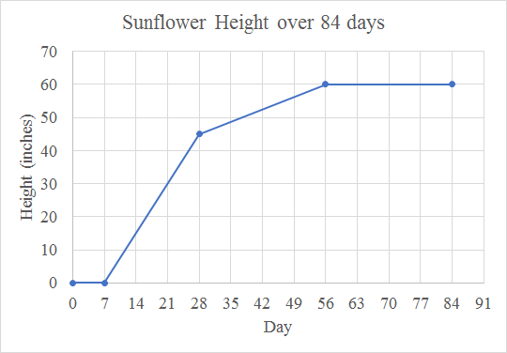
Figure 1: Sunflower height over 84 days.

Sunflowers have 4 stages of life: germination, early, mid, and maturation. In germination, the seed begins to sprout roots. In early growth stages, the plant grows and gains height quickly. In mid growth stages, growth continues, but at a slower pace. At maturation, the plant has reached its full height and continues to live as a full-grown flower.

17. What was the height of the sunflower after 21 days?
- 0 inches
- 19 inches
- 21 inches
- 30 inches

Answer: D
At Day 21, the height of the sunflower is 30 inches, from Figure 1.

DOK 1, IOD

18. What is the maximum height the sunflower reaches?
- 84 inches
- 60 inches
- 56 inches
- The plant does not reach a maximum height.

Answer: B
The maximum height the sunflower reaches is 60 inches, as shown in the graph.

DOK 2, IOD

19. When does the sunflower achieve its maximum height?
- Day 28
- Day 56
- Day 80
- The plant does not reach a maximum height.

Answer: B
The flower achieves a maximum height of 60 inches, and the first day it reaches this height is Day 56. After Day 56, the plant does not gain any more height, and continues at its maximum height of 60 inches.
DOK 2, IOD

20. Jane predicts that growth in the sunflower slows as it uses up all of the nutrients present in the soil, and stops altogether once all of the nutrients have been used up. According to Jane, the sunflower would ___ [blank] if she repeated the experiment but also added more nutrients every day as the sunflower grew.
- Grow taller
- Grow less
- Remain the same
- Die

Answer: A
Jane believes that the sunflower’s growth has slowed because the sunflower has used up all of the nutrients in the soil. Thus, if she added more nutrients, the sunflower would be able to continue growing, and would grow taller.

DOK 2, EMI

21. Jane decides to do another experiment where she adds nutrients to the soil every day until Day 28, but not after that. If her hypothesis is correct, what would you expect to happen with the sunflower? Would it continue growing, and how would its final height compare to a sunflower that she kept adding nutrients to throughout the full time?
Constructed Response

2 points: The student will get full credit if they say that the plant will continue growing, but to a lesser height than a sunflower which constantly received nutrients.
1 point: The student says EITHER that the sunflower will continue growing OR that it will grow to a lesser height than a sunflower which constantly received nutrients.
0 points: The student’s answer is not relevant.

DOK 2, EMI

22. Over how many days did the sunflower experience growth in height?
- 84
- 77
- 56
- 49

Answer: D
The sunflowers grows in height from Day 7 until Day 56, meaning it grew for a total of 49 days.

DOK 2, IOD

23. The students use a watering can to water the sunflower each day. The watering can contains enough water for three days’ of watering. How many times did the students have to refill the watering can for this experiment?
- 18 times
- 24 times
- 28 times
- 32 times

Answer: C
The experiment lasted for 84 days, and the students had to refill the watering can every 3 days. They had to refill the watering can 84/3 times, which is equal to 28.

DOK 2, SI

24. Choose the options from the drop-down menu to make the sentence correct. Hint: There is more than one correct option.
Adding [blank 1] nutrients to the soil while the sunflower is growing will cause it grow [blank 2].

Blank 1 options: More, no, less
Blank 2 options: Not at all, Taller, less

Correct options: more with taller, less with less, no with not at all. The student will get full credit for any correct option

DOK 1, IOD

Block text for Qs 25 - 32

Some students want to compete in a model car race. They built the frame for the model car, and want to test tires made of different materials. They attach each type of tire to the car over several trials, and time the car’s descent down a ramp.
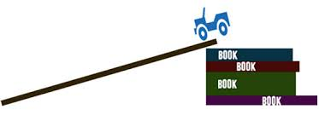

They recorded the times of each of the materials, shown in the figure below. They tested wood, rubber, plastic, and metal tires.
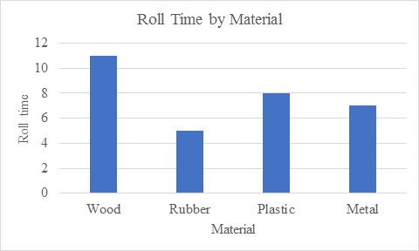
Figure 1: Roll time for the model car with each type of tire.

For the competition, the students must race the model car many times, and are not allowed to change the tires between races. The students also decide to test the durability of different tires, measured as wear on a scale from 1-10, where 10 means the most wear. The table below shows the wear of the different tire materials after many races. The wear of a tire impacts its speed; the greater the wear, the slower the tire will be.

Table 1: Wear of Tires
Material | Races | Wear (1-10)
Wood | 10 | 1
 | 20 | 3
 | 30 | 5
Rubber | 10 | 2
 | 20 | 5
 | 30 | 8
Plastic | 10 | 1
 | 20 | 3
 | 30 | 5
Metal | 10 | 0
 | 20 | 0
 | 30 | 0

25. Which material should the students choose if they want to compete in just one model car race?
A. Wood
B. Rubber
C. Plastic
D. Metal

Answer: B
In a race, the students should choose the tire that will result in the fastest car. The fastest car is the one which took the least time to roll down the incline, which is rubber, in 5 seconds.
DOK 2, IOD

26. After many races (more than 30), which tire will show the most wear?
A. Wood
B. Rubber
C. Plastic
D. Metal

Answer: B
According to Table 1, the rubber tire has the most wear at 30 races. The rubber tire will continue to have the most wear after many races.

DOK 2, IOD

27. If the students need to race the car for 20 races, which type of tire should they choose between the wood and rubber tires? Explain your answer.
Constructed Response

DOK 2, IOD
2 points: The student explains that wood and rubber wear the same AND that rubber is faster in the ramp trials.
1 point: The student explains that wood and rubber wear the same OR that rubber is fast in the ramp trials.
0 points: The student does not give a relevant answer.

28. Below is a graph of roll time against number of races for rubber tires on the car model. Alter the points to represent how the roll time will change with more races.
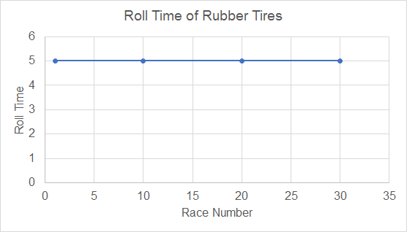

29. In the first experiment, how much time total did the car model spend rolling down the ramp?
A. 8 seconds
B. 11 seconds
C. 25 seconds
D. 31 seconds

Answer: D
In the first experiment, the car model rolled down the ramp 4 times, with the 4 types of tires. To determine the total length of time spent rolling down the ramp, we should add together the roll time of each material. This is 11 + 5 + 8 + 7 = 31 seconds.
DOK 2, IOD

30. David predicts that after enough races, the metal tires will be the best choice. Which of the following might he use to support this idea?
A. The metal tires are the fastest in the first experiment.
B. The metal tires have the most wear after 30 races.
C. The metal tires have the least wear after 30 races.
D. The metal tires are the slowest in the first experiment.

Answer: C
David believes that the metal tires will be the best choice after many races, and he could support this by showing that the metal tires do not wear as fast as the other materials. With more wear, the tires cause the model car to roll slower, so there will eventually come a point when all the other tires will lose enough speed that the metal tires will result in the fastest time.

DOK 2, EMI

31. If the rubber tires have a roll time of 8 seconds on the 30th trial, predict how many trials will occur before the rubber tires reach a roll time of 11 second.
A. 30
B. 60
C. 75
D. 90

Answer: C
In 30 trials, the rubber tire slowed from 6 seconds to 8 seconds for a trial. For the rubber tires to slow from 8 seconds to 11 seconds, they would need another 30 trials to slow another 2 seconds, and then 15 trials to slow another 1 second. All of these trials together would be: 30 trials to 8 seconds + 30 trials to 10 seconds + 15 trials to 11 seconds = 75 trials to 11 seconds.

DOK 2, EMI

32. The judges for the competition change the rule. Now, you can change tires after every 10 races. Which tire would be the best option?
- Wood
- Rubber
- Plastic
- Metal
Why?
Constructed Response

Answer: B (worth 1 point)

2 points: Student states that rubber and wood both show the least wear at 10 races (a rating of 1) AND that rubber is faster in the trials, so it is the best option.
1 point: Student states EITHER that rubber and wood both show the least wear at 10 races, OR that rubber is faster in trials.
0 points: Irrelevant answer.

DOK 2, EMI

Block Text for Qs 33 - 40

Students breed dragonflies as an experiment. The dragonflies can either have two wings or four wings, and are otherwise exactly the same. When the students breed 2 dragonflies with two wings, all offspring also have two wings. When the students breed 2 dragonflies with four wings, all offspring also have four wings. However, when the students breed one dragonfly with two wings with another dragonfly with four wings, all four of the offspring have four wings.

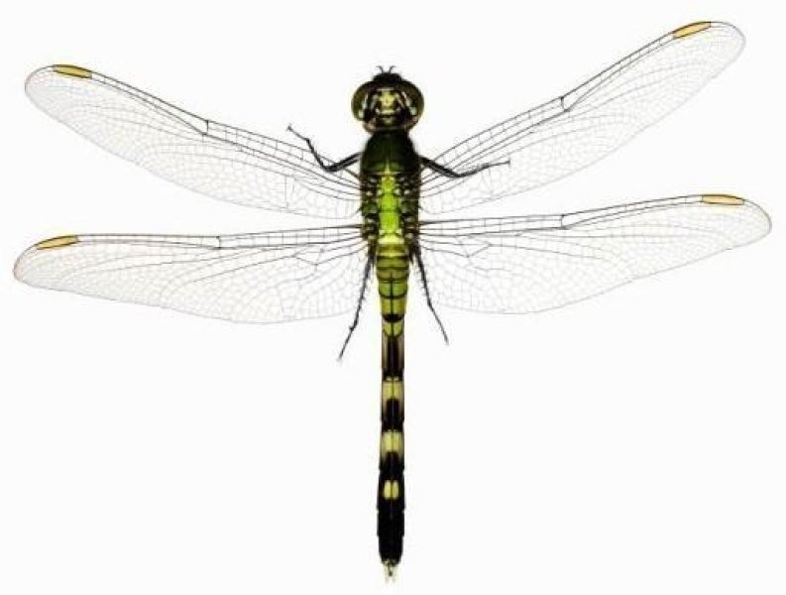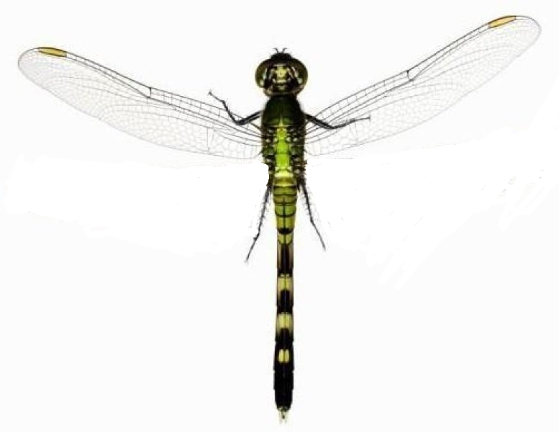
Four Wings Two Wings

Student 1
One student, Ann, claims that dragonflies have genes that define their physical characteristics (number of wings, for example). She states that each parent has two sets of every gene, and pass down one of these randomly to its offspring, so that each dragonfly contains one gene from each of its parents. Ann also believes that the four wings gene (F) is dominant, meaning that as long as the dragonfly has at least one copy of that gene, the dragonfly will have four wings, while the two wings gene (t) is recessive, meaning that the dragonfly will only have two wings if it has two copies of the two wings gene.

Thus, Ann believes that all of the offspring between a four wings and two wings dragonfly have four wings because they receive the recessive wing gene t from one parent and the dominant wing gene F from the other, resulting in all offspring having four wings.

Student 2
Another student, Jason, claims that dragonflies have genes that define their physical characteristics (number of wings, for example). He states that each dragonfly has one set of every gene, and that there is a gene that determines the number of wings. The dragonfly can either have the two wings gene (T) or the four wings gene (F), and offspring of dragonflies will receive either parents’ gene by chance.

33. Which of the students would agree with this statement: Dragonflies have genes.
- Ann
- Jason
- Ann and Jason
- Neither

Answer: C
Both students would agree that dragonflies have genes. However, they disagree on the number of genes that dragonflies have.

DOK 1, IOD

34. Which of the following statements would Ann agree with:

- any dragonfly that has at least one F will have four wings
- any dragonfly with an F will have four wings
- any dragonfly that has at least one f will have four wings
- any dragonfly with an f will have four wings

A.
In order for a dragonfly to have two wings according to Ann’s hypothesis, it needs to have both t’s, so tt is the only dragonfly that will have two wings by her theory. Similarly, according to Jason’s hypothesis, any dragonfly with a T will have two wings.

DOK 2, IOD

35. If the students breed two dragonflies with four wings, and one of the offspring has only two wings, whose hypothesis would this support?
- Ann
- Jason
- Ann and Jason
- Neither

Answer: A
By Jason’s hypothesis, each dragonfly could offer the four wing gene, and all offspring would be guaranteed to have four wings, so this experiment would not support Jason’s theory. However, by Ann’s hypothesis, dragonflies that have one dominant, F gene, and one recessive, t gene, could each offer up on t gene, resulting in offspring with two t genes, and thus two wings. This experiment therefore supports Ann’s hypothesis.

DOK 3, EMI

36. If a dragonfly had four wings, but lost two in a tragic accident, which gene would that dragonfly have, according to Jason’s hypothesis?
- FF
- Ft
- T
- F

Answer: D
If the dragonfly had four wings, then by Jason’s hypothesis, it must have the gene F. Losing wings in an accident would not change the gene.

DOK 1, EMI

37. Between the two parents and their offspring describe in the experiment, how many wings total did the dragonflies have?
- 20
- 18
- 16
- 12

Answer: B
One parent had two wings, while the other parent and all three offspring had four. So, the total number of wings is 2 + 4 x 4 = 18.

DOK 2, SI

38. Which experiment listed below could support both students claims?
- Crossing two 2-winged dragonflies, offspring has 4 wings
- Crossing two 4-winged dragonflies, offspring has 2 wings
- Crossing two 4-winged dragonflies, some offspring have 2 wings and some have 4 wings
- Crossing two 4-winged dragonflies, offspring has 4 wings

Answer: D
Jason’s hypothesis would not be supported by any experiment in which two dragonflies with the same number of wings had offspring with a different number of wings, so options A, B, and C cannot be correct. Option D is correct; it supports Jason’s hypothesis because either parent could have given the offspring a F gene. This also supports Ann’s hypothesis because the offspring could have received a dominant gene from either or both parents and thus also had 4 wings.

DOK 2, SI

39. In another experiment, you cross a two-winged dragonfly with a four-winged dragonfly. Assume, for Ann’s hypothesis, that the two-winged dragonfly has the genes tt and the four-winged dragonfly has the genes FF. Which of the distributions below shows how many of the offspring of these two dragonflies would have four wings, according to each student’s hypothesis?
- 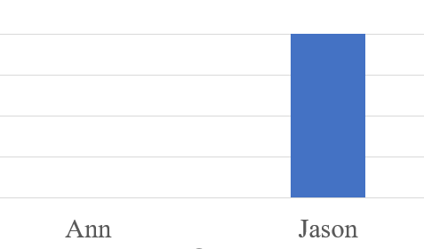
- 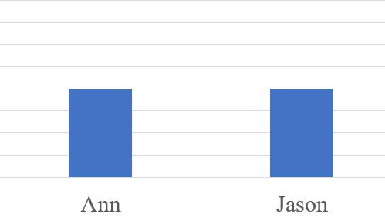
- 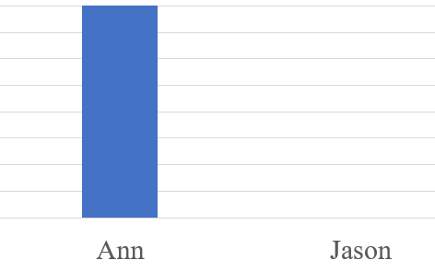
- 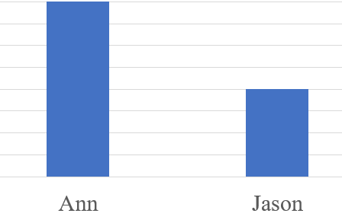

Answer: D
According to Ann’s hypothesis, all of the offspring would receive the dominant F gene and recessive t gene, meaning they would all have four wings, so the correct distribution would show Ann predicting high numbers of dragonflies with four wings. Additionally, according to Jason’s hypothesis, each dragonfly offspring would receive either the F gene or the T gene, meaning about half of the offspring would have four wings, so Jason’s estimation bar should be half the height of Ann’s. The only option that fulfills these requirements is D.

DOK 2, EMI

40. A third student, Ada, has a hypothesis about dragonflies. Which of the following options, listed below, would Ann disagree with Ada about?
Ada’s hypothesis: Dragonflies have genes that determine their physical characteristics, such as number of wings. Each parent has two sets of every gene, and pass down one of these randomly to its offspring, so that each dragonfly contains one gene from each of its parents. However, even though each dragonfly has two copies of each gene, it will randomly display the characteristics of either gene. If a dragonfly has one two-wing gene and one four-wing gene, then it will randomly have either two or four wings, in an unpredictable way.

Circle all that apply:

- There is a dominant and recessive gene for each characteristic
- Dragonflies have two genes
- Parents pass down genes to their offspring
- A dragonfly with a four-wing gene will always four wings

This question: instead of choosing one option, there should be checkboxes next to each option.

2 points: The students checks both A and D.
1 point: The student checks EITHER A OR D.
0 points: The student does not check A or D.

DOK 2, EMI

