Science Curriculum Pattern

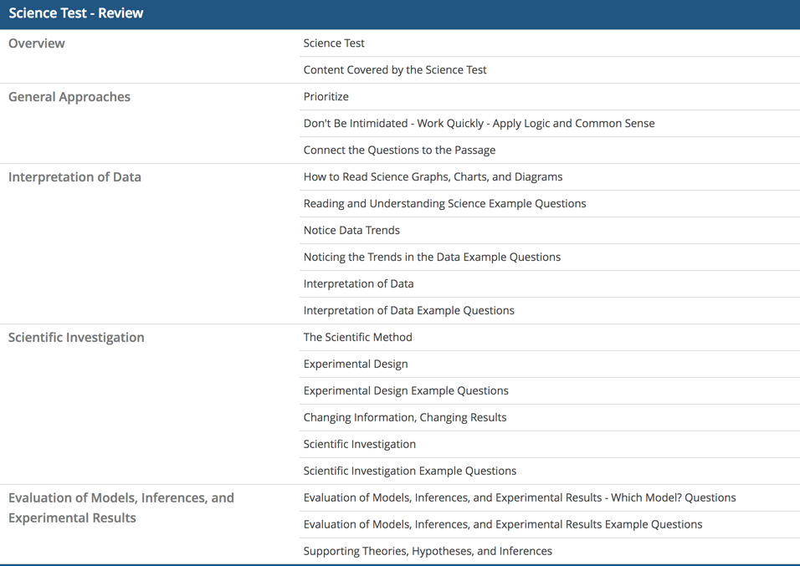

How to Read Science Graphs, Charts, and Diagrams

Know Your Graphs
The science test evaluates your comprehension of tables and graphs. So if you like science, reading, math, or even just checking the stats of your favorite MLB pitcher, you can read a table, and you’ve got it covered.
The ability to quickly identify the most important features of a graph can save a tremendous amount of time. These features include the following:
- the type of graph
- what the graph represents (what each axis stands for)
- patterns in the data

Common Graph Types
Line graph. A line graph typically shows the relationship between two variables, one on the x-axis (the horizontal line) and one on the y-axis (the vertical line). The x-axis represents the independent variable, which the researcher purposefully changes, while the y-axis represents the dependent variable, which may be changed by the independent variable. A solid line is used to show the data.
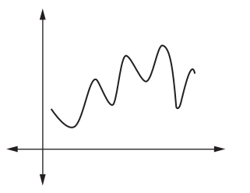
Time is frequently represented on the x-axis. For many experiments, time is the independent variable; the other variable changes as time goes on.
Scatterplot. A scatterplot is similar to a line graph in terms of the axis and variables; the data, however, are not shown by a solid line, but as points scattered throughout the graph, with each point representing one trial in an experiment. Sometime, a “line of best fit” (shown as a dotted line in the graph below) is used to trace the general path of the data. This line doesn’t connect the points on the graph; in fact, it may not pass directly through any points.
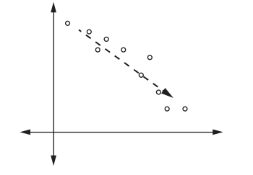
Bar graph While a bar graph uses the same axes and independent/dependent variables as a line graph, it portrays each trial with a bar.
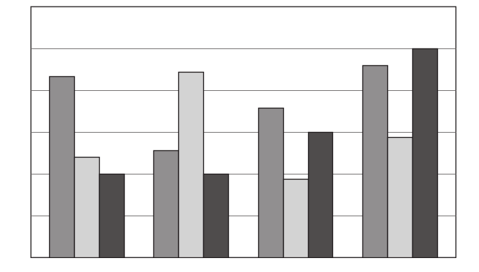
Pie chart A pie chart is a circle divided into segments that show relative percentages of several elements. A pie chart doesn’t show variables; instead, it reflects the relative sizes of the components of a whole.
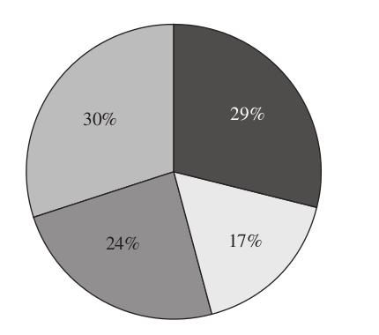
While a pie chart itself cannot show a trend, a series of pie charts can.
What a Graph Represents
For scatterplots and line and bar graphs, the two axes indicate what the graph is depicting. For example, if the x-axis represents temperature and the y-axis represents pressure, the graph shows the relationship between temperature and pressure. For a pie chart, the whole and the segments are labeled so that they can be quickly identified.
Some science graphs use the same set of axes and variables to plot several sets of data. For example, a graph may plot four different gases with respect to temperature on one axis and pressure on the other; this graph displays four sets of data for potential trends instead of one.

How to Read Science Graphs, Charts, and Diagrams Example Questions
Passage I
Classifications | Minimum | Optimum | Maximum
Psychorophile | below 0° | 10°–15° | below 20°
Psychrotrophes | 0°–5° | 15° | 30°
Mesophiles | 5°–25° | 18°–45° | 30°–50°
Thermophiles | 25°–45° | 50°–60° | 60°–90°
Bacteria can be categorized by how they respond, as indicated by reproduction and growth, to certain temperatures. They are grouped into four categories — psychropiles, psychrotrophes, mesophiles, and thermophiles — based on their growth respond to certain temperatures. Minimal growth point is the lowest temperature at which the bacteria will reproduce. Optimum growth point is the temperature at which the bacteria reproduce most efficiently. Maximum growth point is the very highest temperature to which the bacteria will respond, beyond which the bacteria will not reproduce at all. Table 1 lists the types of bacteria as well as the growth points for each.
Table 1
Growth points or ranges

1. A new bacteria was discovered by scientists. It reproduces best at 55°C and does not show any new growth if exposed to temperatures above 65°C. This bacteria can most likely be classified as a:
- psychrophile
- psychrotroph
- mesotroph
- thermophile
Solution: The correct answer is D.
Thermophiles are shown by Table 2 to reproduce best, that is to have an optimum growth point, between 50°C and 60°C. A bacteria that reproduces at 55°C would likely be classified there. Further, if the bacterium does not show any new growth above 65°C, that also fits within the range of maximum growth points for thermophiles of between 60° and 90°C.

Passage II
A solute is any substance that is dissolved in another substance, which is called the solvent.
A student tested the solubility (a measure of how much solute will dissolve into the solvent) of six different substances. The solubility of a substance at a given temperature is defined as the concentration of the dissolved solute that is in equilibrium with the solvent.
Table 1 presents the concentration of dissolved substances in 100 grams of water at various temperatures. The concentrations are expressed in grams of solute per 100 grams of water.
Concentration of solute (g/100 g H₂O)

Temp (°C) | KCl | NaNO₃ | HCl | NH₄Cl | NaCl | NH₃
0 | 28 | 72 | 83 | 29 | 37 | 90
20 | 33 | 86 | 72 | 37 | 37 | 55
40 | 39 | 105 | 63 | 46 | 38 | 36
60 | 45 | 125 | 55 | 55 | 38 | 23
80 | 51 | 145 | 48 | 66 | 39 | 14
2. The graph below best represents the relationship between concentration and temperature for which of the following substances?
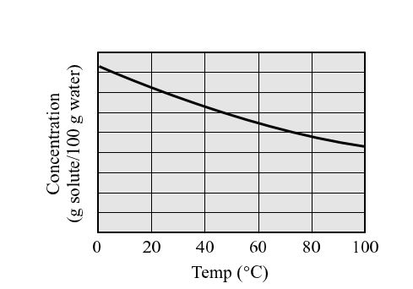
- HCl
- NaNO₃
- NaCl
- KCl
Solution: The correct answer is A.
In this question you are asked to look at the tends in the substances, especially at how their concentrations change with increasing temperature. In the data set, some substances become more soluble with increasing temperature, while some become less soluble. The graph represents the solubility curve for a substance that gets less soluble with increasing temperature. Looking at the possible answer choices. HCl is the only logical choice.
Report Content Errors

Discuss

Reading and Understanding Science Example Questions
The science test includes data represented in charts, tables, and graphs.

Passage I
Directions: Questions 1–4 refer to the following table.
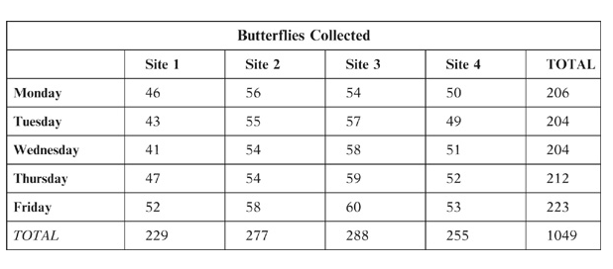
1. How many butterflies were collected at Site 3 on Wednesday?
Solution: To answer this question, find the column representing Site 3 and follow it down until it intersects with the row representing Wednesday. You will see that 58 butterflies were collected at Site 3 on Wednesday.
2. What is the greatest number of butterflies collected on any one given day?
Solution: To answer this question, find the largest total for a single day in the table, disregarding the totals because the question asks about a single day. The greatest number of butterflies collected on any given day is 223, which is the number of butterflies collected on Friday.
3. At which site were the fewest butterflies collected on Friday?
Solution: To answer this question, find the row representing Friday and then locate the smallest number in the row. Next, look at the heading of the column that corresponds to that small number. The table shows that 52 butterflies were collected at Site 1 on Friday, fewer than from any other site.
4. Which site shows a constant increase in the number of butterflies collected daily throughout the week?
Solution: To answer this question, find the column that shows a continual increase from Monday through Friday in the number of butterflies collected. Only Site 3 fits this criterion. The other sites do not show a constant increase in the number of butterflies collected throughout the week.

Passage II
Directions: Questions 5–8 refer to the following graph.
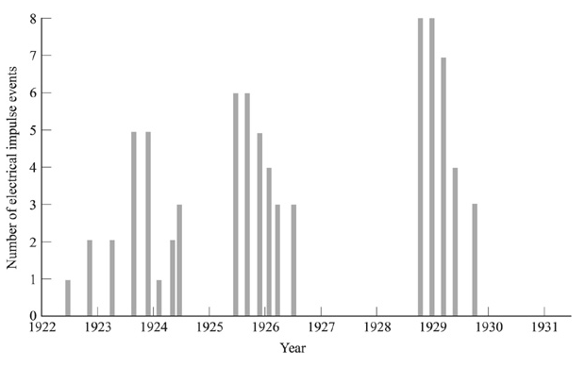
5. Which of the following one-year spans showed fewer than 10 electrical impulse events in all?
- 1923–1924
- 1925–1926
- 1926–1927
- 1930–1931
Solution: The correct answer is D. To quickly answer this question you can look at the graph and note that from 1930 to 1931, there were no electrical impulse events. Because there will never be more than one correct answer, you can assume that each of the other choices includes 10 or more electrical impulse events. Look at the span indicated in each of the answer choices and count the total number of electrical impulse events:
1923–1924: there were a total of 12 electrical impulse events.
1925–1926: there were a total of 17 electrical impulse events.
1926–1927: there were a total of 10 electrical impulse events.
1930–1931: there were a total of 0 electrical impulse events.
6. Which of the following one-year spans showed the highest number of electrical impulse events overall?
- 1922–1923
- 1923–1924
- 1924–1925
- 1925–1926
Solution: The correct answer is D. Remember to note the number of electrical impulse events represented by each bar on the graph; you cannot simply count the number of bars to find the correct answer to this question. Look at the span indicated in each of the answer choices and count the total number of electrical impulse events:
1922–1923: there were a total of 3 electrical impulse events.
1923–1924: there were a total of 12 electrical impulse events.
1924–1925: there were a total of 6 electrical impulse events.
1925–1926: there were a total of 17 electrical impulse events.
Therefore, the span from 1925–1926 showed the highest overall number of electrical impulse events.
7. How many electrical impulse events occurred from 1923 through 1925?
- 6
- 11
- 18
- 25
Solution: The correct answer is C. Remember to note the number of electrical impulse events represented by each bar on the graph; you cannot simply count the number of bars to find the correct answer to this question. From 1923–1924, there were a total of 12 electrical impulse events, and from 1924–1925, there were a total of 6 electrical impulse events. Thus, a total of 18 electrical impulse events occurred from 1923 through 1925.
8. During which year were no electrical impulse events recorded?
- 1922
- 1925
- 1927
- 1928
Solution: The correct answer is C. According to the graph, between 1927 and 1928 (in other words, during 1927) no electrical impulse events were recorded. You need to look at the entire span of the year, not just at the hash mark that represents the beginning of each year.

Passage III
Directions: Questions 9–12 refer to the following figure.

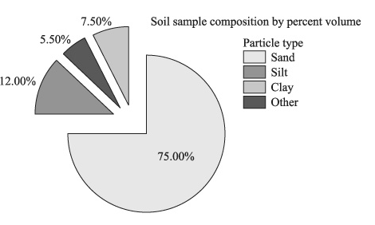
9. According to the figure, what percent of the soil sample’s volume is composed of sand?
Solution: To answer this question, find the representation of sand on the key. According to the pie chart, sand represents 75% of the soil sample.
10. According to the figure, sand and silt together comprise what percentage of the soil sample?
Solution:
To answer this question, find the representation of sand and silt on the key. According to the pie chart, sand represents 75% of the soil sample and silt represents 12% of the soil sample. Therefore, together they represent 75% + 12%, or 87% of the soil sample.
11. Which particle type’s volume comprises the least portion of the soil sample volume?
Solution: To answer this question, first find the smallest “slice of the pie.” The pie chart shows that 5.5% of the sample is made up of something other than sand, silt, or clay; therefore, you should now look for the next smallest “slice.” When you do this, you see that clay makes up only 7.5% of the soil, less than either silt or sand.
12. A certain plant will only grow in soil that is composed of at least 25% silt or clay or a combination of the two. Will this plant grow in the soil sampled?
Solution: The plant will not grow in the soil sampled because, according to the pie chart, the total percentage of silt and clay is only 19.5% (12% + 7.5%).

Notice Data Trends
Many of the science test questions reward test takers who can spot trends in the data presented. When charts or graphs are given, take a moment to figure out which variables are being charted and note any apparent relationships between them. A direct relationship is when one variable increases as the other increases. An inverse relationship is when one variable decreases as another increases.
If a question asks about changes in several variables, or relates one variable change to another variable change, you may have a hard time keeping them straight — or even lose track of them by the time the question is through! Take each question one sentence at a time. For each sentence, try making a note of every variable mentioned and its change (increase or decrease) with a letter abbreviation (ex: Volume = V) and an arrow Up or Down (↑ or↓).
A trend is a pattern showing a simple and straightforward relationship among the data. To identify a data trend, try to compose a sentence that summarizes what is happening in the graphic.
A word of caution, however: there might not be a trend. Most graphics have a trend, but some don’t. It’s important not to impose a trend on data where there isn’t one.
The speed with which you can identify trends impacts how quickly you’re able to understand a passage and answer the questions.

Some Possible Data Trends
- Direct Variation: Variables 1 and 2 increase or decrease simultaneously
- Inverse Variation: Variable 1 increases, Variable 2 decreases (or vice versa)
- Variable 1 increases, Variable 2 increases, then decreases
- Variable 1 increases, Variable 2 decreases, then increases
- Variable 1 increases, Variable 2 increases/decreases, then plateaus (flat-lines)
- Exponential growth: Sometimes referred to as a “J curve,” exponential growth begins increasing slowly, then increases more and more quickly:
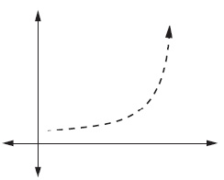
This type of curve is common in unchecked population growth when a population is growing without restraints in food or habitat supply. Human population growth, for example, is roughly exponential.
- Logistic growth Sometimes referred to as an “S curve,” logistic growth resembles exponential growth in the beginning, but then encounters limits to growth and levels off:
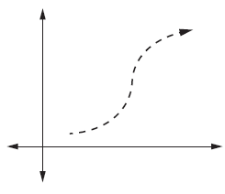
A colony of bacteria on a petri dish, for example, grows rapidly at first, but then runs out of food and the population levels off.

Unfamiliar Diagrams
If you encounter an unfamiliar type of diagram or model in the course of the science test, don’t try to understand the entire graphic at once; read the question first, so that you can begin a targeted search for the necessary information. In this way, you can save time as well as mental energy.
A graphic may include multiple data sets, such as several lines on a graph or several columns in a table. In addition to understanding how two variables are related, you may need to determine how the data sets differ with regard to those variables. Here is a line graph in which several data sets are presented:
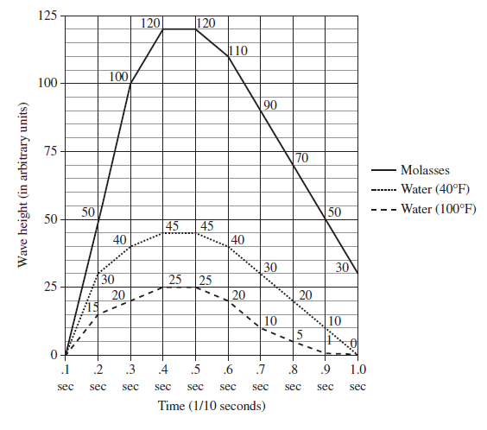
In this line graph, each data set is represented by a different style of line. In general, the graph shows that as time goes on, wave height increases, then decreases. The wave height of molasses changes most drastically, the wave height of water at 40°F changes much less, and that of water at 100°F changes least. The key to understanding graphics with multiple data sets is to recognize not only the over all trends, but also the similarities and differences among the data sets themselves.
Here's an example question:
The molar heat of fusion ΔH_{fus} is the amount of heat necessary to melt (or released on freezing) 1.00 mole of a substance at a constant pressure.
The following table lists molar heats of fusion, boiling points, and melting points for several elements.
Element | Melting point (°C) | Boiling point (°C) | ΔH_{fus} (kJ/mol)
Calcium | 839.00 | 1,484.00 | 8.54
Silver | 961.92 | 2,212.00 | 11.30
Iron | 1,535.00 | 2,750.00 | 13.80
Nickel | 1,453.00 | 2,732.00 | 17.46
Note: measured at a pressure of 1 atmosphere (atm).

1. According to the table, as the energy required to melt 1.00 mole of the given elements increases, the melting points:
- increase only.
- decrease only.
- increase, then decrease.
- neither increase nor decrease.
Solution: The correct answer is C. The passage states that, "The molar heat of ΔH_{fus} is the amount of heat necessary to melt (or freeze) 1.00 mole of a substance at a constant pressure." According to the table, as the molar heat of fusion increases, the melting point increases from calcium, to silver, to iron, then decreases for nickel. By noticing a trend in the data, the question becomes easier to answer correctly.

Noticing the Trends in the Data Example Questions

Passage I
Margarita decides to enter her school's science fair. She has always loved flowers and wants to incorporate them into her project. In the end, Margarita decides to test the effectiveness of different types of plant food (fertilizer) on a certain type of rose bush. Her goal is to determine which fertilizer produces the tallest rose bushes with the greatest number of flowers.
The results of Margarita's experiment are recorded on the graphs below.
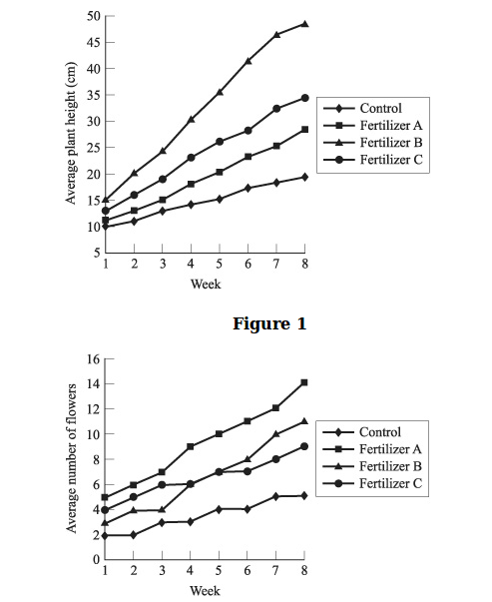
Figure 2
1. Based on Figure 1, which fertilizer affected plant height the most?
- Fertilizer A
- Fertilizer B
- Fertilizer C
- All were equally effective.
Solution: The correct answer is B. To answer this question, you should look at Figure 1 and compare the plant heights in Week 1 to the plant heights in Week 8. You can see that the line representing the height of the plants that received Fertilizer B is very steep, which indicates the greatest amount of change. The plants that received Fertilizer B grew about 30 centimeters from Week 1 to Week 8.
2. At 5 weeks, about how much taller, on average, were the plants receiving Fertilizer B compared to those not receiving any fertilizer?
- 15 cm
- 20 cm
- 30 cm
- 35 cm
Solution: The correct answer is B. According to Figure 1, the plants that received Fertilizer B had an average height of about 33 centimeters at 5 weeks, whereas the plants in the control group (those not receiving any fertilizer) had an average height of about 13 centimeters at 5 weeks. Therefore, the plants receiving Fertilizer B were, on average, about 20 centimeters taller than the plants receiving no fertilizer.
3. During which two weeks did Fertilizer B and Fertilizer C yield the same average number of flowers?
- Weeks 1 and 2
- Weeks 3 and 4
- Weeks 4 and 5
- Weeks 7 and 8
Solution: The correct answer is C. To answer this question, find the spot on Figure 2 at which the lines representing Fertilizers B and C intersect; this is the point at which the data is identical. Because the lines intersect at Week 4 and Week 5, those are the weeks during which the plants receiving Fertilizer B and C produced the same average number of flowers.

Interpretation of Data
Some science questions may ask you to interpret and analyze the data shown in tables, charts, graphs, and figures that are presented similarly to those that you might find in a scientific journal or other scientific publication. Following is an example passage and several questions. The answers and explanations are given at the end of this chapter.

Data Trend and Relationships Between Variables Questions
This type of question asks you to look at a chart or graph and decide what happens to one thing as another changes, like “as heat increases, what happens to volume?” See the lesson "Notice Data Trends" for detailed information on data trends and relationships between variables.

Example Questions
When Mikayla plays Tetris 2 hours per day, she gets to Level 8, and when Mikayla plays 4 hours per day can get to Level 83, what Level can Mikayla reach if she plays 3 hours per day?
- 17
- 22
- 46
- 67
Solution: The correct answer is C. Since 3 hours is halfway between 2 hours and 4 hours, we just want a level number also halfway between 8 and 83, and they will only give you one number even remotely halfway between! This will not require complex calculations, just some simple estimation and rounding.
Round 8 to 10, and Round 83 to 80. Halfway between 10 and 80 is 45, which is closest to answer choice C
Directions: The following sample passages involves interpretation of a graphic. Select the best answer using the information in the related passage.
PASSAGE I
Fossils found in a certain mountainous part of the Western United States have been uncovered at varying regions on hillsides. Fossils (imprints of ancient plants and animals made by being buried in sediment, mud, or other minerals and compacted for hundreds of thousands of years) are primarily found in the sedimentary limestone that is common in the area. The different parts of the hillsides where fossils have been found are marked on the following diagram.
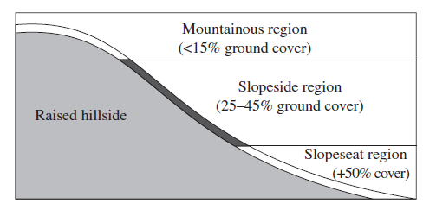Raised Hillside Diagram
The diagram shows that three regions of the hillside where fossils have been discovered. The regions are differentiated based on the percentage of floral ground cover (plants, shrubs, trees, etc.) that exists at that particular height. The mountainous region is highest, but has the lowest percentage of ground cover. In the middle is the slopeside region, which has a moderate amount of ground cover, and at the base of the hill is the slopeseat region, which has an abundance of ground cover.
1. A fossil found in the region discussed above has been found in an area with 27% ground cover. What region has it been found in?
- The mountainous region
- The slopeside region
- The slopeseat region
- Not enough information is given.
Solution: The correct answer is B. The first question asks you to identify a region with 27% ground cover. The slopeside region (25–45% ground cover) clearly meets this requirement.
2. According to the graph above, what is the cutoff height between the mountainous region and the slopeside region?
A. 15 feet in height
B. 25 feet in height
C. 45 feet in height
D. Regions are defined by ground cover percentage, not height.
Solution: The correct answer is D. This question asks you to determine the cutoff height between the mountainous and slopeside regions. Since the regions are defined by ground cover percentage, not by height in feet, just use the graph and discern the height at the border between "mountainous" and "slopeside."

PASSAGE II
Lake Alexander existed between 9400 and 12,800 years ago in southern Canada. The lake was formed when a large glacier flattened the land and created a dip below sea level. Soil excavated from the area where the lake stood reveals information about the time period that the sediments were deposited. Figure 1 shows a cross section of the sediments (sand and gravel and brown till) and bedrock in the area.
Figure 2 shows the copper levels of groundwater taken from samples of the top 45 m of sediment at two sites along the same cross section. In general, copper enters groundwater through corrosion of household plumbing systems or erosion of natural copper deposits. Smaller copper levels indicate greater distance from urban areas and from natural copper deposits.
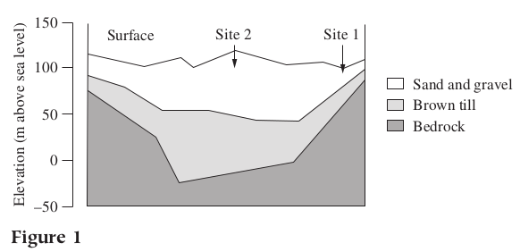
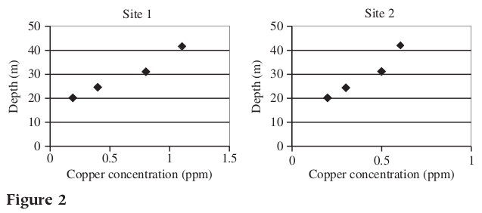
3. According to Figure 1, which of the following has the thinnest deposit?
- Sand and gravel at Site 1
- Sand and gravel at Site 2
- Brown till at Site 2
- Bedrock at Site 1
Solution: The correct answer is A. The question tells us to look at Figure 1. If it doesn’t tell you where to look, just scan the tables and graphs for the one that has the keywords from the question. Don't be afraid to look for something obvious. This question asks for the thinnest layer on the diagram. So, looking at Figure 1, try the answers and use the process of elimination.
4. According to Figure 1, as the thickness of the brown till deposit increases from Site 1 to Site 2, the thickness of the sand and gravel above it:
- increases
- remains the same
- decreases
- first decreases then increases
Solution: The correct answer is A. Look at Figure 1 and look at how thick the sand and gravel layer is from Site 1 to Site 2. As long as you stay focused, you'll get the right answer. From Site 1 to Site 2, the thickness of the sand and gravel layer, shown in white on the diagram, increases. You might think that it increases and then decreases, but that is not an answer choice anyway. Notice that choice D is incorrect because it says the opposite.

Interpretation of Data Example Questions

Passage I
Lake Alexander existed between 9,400 and 12,800 years ago in southern Canada. The lake was formed when a large glacier flattened the land and created a dip below sea level. Soil excavated from the area where the lake stood reveals information about the time period that the sediments were deposited. Figure 1 shows a cross section of the sediments (sand and gravel and brown till) and bedrock in the area.
Figure 2 shows the copper levels of groundwater taken from samples of the top 45 m of sediment at two sites along the same cross section. In general, copper enters groundwater through corrosion of household plumbing systems or erosion of natural copper deposits. Smaller copper levels indicate greater distance from urban areas and from natural copper deposits.
1. Based on the data in Figure 2, at Sites 1 and 2 the deposit of lowest copper concentration in the groundwater was recorded at a depth of:
- 5 m
- 20 m
- 24 m
- 50 m
Solution: The correct answer is B. The question tells you exactly where to look for the answer. In both graphs of Figure 2, the lowest copper concentrations are at a depth of 20 m.

Passage II
Figure 1
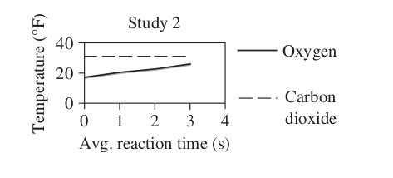
2. Based on the average reaction times used in Study 2, compared with the corresponding temperature for oxygen, carbon dioxide has a temperature at a given average reaction time that is:
- always lower
- always the same
- always higher
- sometimes lower and sometimes higher
Solution: The correct answer is C. The question asks how the temperatures of oxygen and carbon dioxide compare. The dashed line, which represents carbon dioxide, is always higher than the solid line, which represents oxygen. So the temperatures for carbon dioxide are always higher than the temps for oxygen.

Passage III
Table 1
Effusion Time (sec) | Percent Concentration in Region 2
0 | 12.3
9 | 29.7
12 | 31.8
15 | 43.9
3. The effusion time of the gas was the time required for the gas to reach 20% concentration in region 2. The effusion time for the gas was:
- less than 9 s
- between 9 and 12 s
- between 12 and 15 s
- greater than 15 s
Solution: The correct answer is A. Table 1 shows that at 9 s it reached 29.7%. So it reached 20% before 9 seconds.

Passage IV
Figure 1
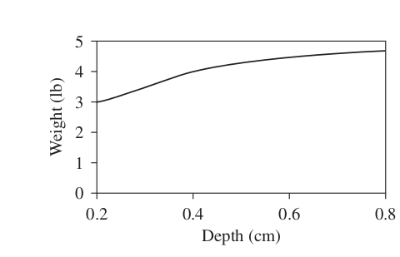
4. According to Figure 1, a rabbit footprint found 0.6 cm deep in wet loam soil would indicate that the rabbit weighed which of the following?
- 2.5 lb
- 3.5 lb
- 4.5 lb
- 5.5 lb
Solution: The correct answer is C. The graph shows that at 0.6 cm, weight is between 4 and 5 lb. Notice that only one answer is in this range.

Passage V
Experiment 1
 | Rayon | Wool | Vinyl | Fiberglass
Heat retention | 71% | 82% | 89% | 92%
Linear expansion (mm) | 0.91 | 0.84 | 0.95 | 0.12
5. Based on the results of Experiment 1, if an engineer needs an insulation that retains over 90 percent heat, which of the following should she choose?
- Rayon
- Wool
- Vinyl
- Fiberglass
Solution: The correct answer is D. Circle the key words in the question if you feel confused. We want to retain heat, so look at the heat retention row on the table. Fiberglass is the only one above 90%. Your eyes might see the 0.91 for rayon in the linear expansion row first, but make sure to answer the question, which specifically asks for heat retention.

Passage VI
Experiment 1
A study was conducted to determine whether a salt/sand alternative proved effective on frozen road surfaces. Researchers predicted that a given amount of salt/sand mixture could be used interchangeably with ordinary road salt.
Ordinary road salt, composed primarily of NaCl, was compared with a 50% NaCl and 50% sand mixture. The salinity (salt concentration) of the road salt used in both was identical. The scientists gathered data from road crews in Dunnville, Ontario. The road crews reported the pounds of salt or salt/sand mixture needed for a 1-mile stretch of a two-lane road. The results are presented in the table.
Road surface temperature | NaCl (lb) | NaCl and sand (lb) | Application
> 0 | 100 | 200 | As needed
−4 to −1 | 200 | 400 | As needed
−9 to −5 | 250 | 500 | Every 3 h
−14 to −10 | 300 | 600 | Every 2 h
6. The main purpose of the experiment was to determine:
- the number of applications of road salt needed for varying road surface temperatures
- the effectiveness of a salt/sand mixture in above-zero conditions
- the salinity levels of ordinary road salt and of the salt/sand mixture
- the number of pounds of ordinary road salt and salt/sand mixture needed
Solution: The correct answer is D. The paragraph told us that the researchers were testing to see if “a given amount of salt/sand mixture could be used interchangeably with ordinary road salt.” Use the process of elimination. Choice A was mentioned in the table, but it’s a part of the results and not the main purpose. Choice B should say “below zero,” and choice C is irrelevant since the salinity levels were told, in the paragraph, to be equal. Look for the obvious and don’t get intimidated!
7. The table shows that as road surface temperatures decrease, frequency of application of road salt increases. This is most likely so because at lower temperatures:
- the road surface refreezes more quickly.
- more salt is needed per application.
- salt is more effective than salt/sand.
- salinity decreases.
Solution: The correct answer is A. Don’t get intimidated. Just use common sense. Why would you need to apply salt more frequently when it’s colder? Use the process of elimination.
8. Researchers wanted to reduce the amount of salt used because it harms plants near the road and potentially contaminates nearby soil deposits and water tables. Does the study indicate that using the salt/sand mixture reduces the use of salt?
- Yes; the salinity of the mixture was identical to that of the ordinary road salt.
- Yes; the mixture contains only 50% salt.
- No; the temperatures varied and do not show consistent data.
- No; the pounds needed for the mixture were twice the pounds needed for ordinary road salt and therefore had equal amounts of salt.
Solution: The correct answer is D. The salt/sand mixture did not cut down on salt, since they needed twice as much of the mixture per application, keeping the actual pounds of salt the same.

The Scientific Method
The Scientific Method is one process by which experimental scientists attempt to construct an accurate representation of the world. This process is helpful in scientific investigation and the acquisition of new knowledge, based upon actual physical evidence and careful observation. The scientific method is a means of building a supportable, documented understanding of our world. Understanding the Scientific Method can help you understand the structure of the science test passages
The Scientific Method includes four essential steps, which typically occur in the following methodological order:
- Observation
- Hypothesis
- Prediction
- Experiment
During the observation phase, the experimenter directly observes and measures the phenomenon that is being studied. Careful notes should be taken and all pertinent data should be recorded so that the phenomenon (the thing observed) can be accurately described.
The experimenter then generates a hypothesis to explain the phenomenon. He or she speculates as to the reason for the phenomenon based on the observations made and recorded.
Next, the experimenter makes predictions to test the hypothesis. These predictions are tested with scientific experiments designed to either prove or disprove the hypothesis. The Scientific Method requires that any hypothesis either be ruled out or modified if the predictions are clearly and consistently incompatible with experimental results.
If the experiments prove the hypothesis, it may come to be regarded as a theory or law of nature. However, it is possible that new information and discoveries could contradict any hypothesis at any stage of experimentation.

Experimental Design
Many experiments include the same basic components, and understanding how to design and execute an experiment can help you understand the science test passages.
An example of an experimental design: If we want to find out how the consumption of sugar impacts the fatigue level of test takers, we would need at least a few test takers who do not consume any sugar so that we can measure the “baseline” or “natural” fatigue level of test takers for comparison to the group that consumes sugar. If there was no control group, we wouldn’t be able to say for sure that sugar has any impact on the fatigue level of test takers. If all of the test takers consumed sugar, and if all of them were sleepy, we would face a confounding-of-variables situation because the sleepiness could be caused by any other factor that the group had in common, like the test itself!
Some of the science test passages refer to “studies” rather than experiments. An experiment is an artificial situation that is created by the researcher. A study is characterized by careful, documented observation. Nevertheless, studies can include some of the elements of experiments, such as control groups.

Independent and Dependent Variables
Understanding variables is not only critical for solving science problems, but also valuable in comprehending how science explores the natural world. Scientists often ask questions like “How does this work?” and “Where did that come from?” It’s difficult to answer such questions without breaking them down into smaller questions.
Independent and Dependent Variables in an Experimental Design
A grade-school scientist may want to explore what makes certain plants grow taller than others. To design an experiment, she first needs to select a single variable to test—say, the amount of water that each plant gets. The variable that the scientist chooses to change is the independent variable, and it usually varies in logical, progressive increments (for instance, 25 mL, 50 mL, and 100 mL of water daily).
The scientist could measure two variables: the effects of both water and fertilizer on the growth of plants. She could apply no water and no fertilizer to the first plant, a little water and a little fertilizer to the second plant, and a lot of water and a lot of fertilizer to the third plant. She may learn that the first plant dies, the second plant grows a little, and the third plant grows quite tall.
For more on
Independent Variable: The variable that the scientist chooses to change
- Usually varies in logical, progressive increments (for instance: Amount of water – 25 mL, 50 mL, and 100 mL of water daily)
- Almost always on the x-axis
Dependent Variable: The variable that changes because the independent variable changes
- Variable the scientist is unsure of
- Almost always on the y-axis
As the scientist changes the independent variable, it is hoped that the dependent variable (observed by the experimenter) will change as a result, and that a relationship can be established.
A control is an element of the experiment that is not subjected to the same changes in the independent variable as the experimental elements are.
Independent and Dependent Variable Pairs - Examples
- Independent variable: amount of food; Dependent variable: length of caterpillars.
- Independent variable: hours spent studying; Dependent variable: grade in the class.
- Independent variable: temperature of the water; Dependent variable: heart rate of the fish.
- Independent variable: time measured in days; Dependent variable: plant height.
When scientists design experiments to test their hypotheses, they have to be careful to avoid “confounding variables.” This means that they have to isolate, as much as possible, one variable at a time so that they can reveal the relationships between the variables, if any.

Identifying Independent and Dependent Variables Example Questions
1. John wants to see how the amount of food he gives to his caterpillars will affect how long they become.
Solution:
Independent variable: amount of food
Dependent variable: length of caterpillars
2. Priyanka wants to explore whether there is a relationship between the grade a student receives in a certain class and the number of hours he spent studying.
Solution:
Independent variable: hours spent studying
Dependent variable: grade in the class
3. Vlad wants to see if the temperature of the water in the fish tank affects the heart rate of his fish.
Solution:
Independent variable: temperature of the water
Dependent variable: heart rate of the fish
4. Allison wants to learn how the growth of a plant changes over its first 15 days.
Solution:
Independent variable: time measured in days
Dependent variable: plant height

Experimental Design Example Questions
Margarita decides to enter her school's science fair. She has always loved flowers and wants to incorporate them into her project. In the end, Margarita decides to test the effectiveness of different types of plant food (fertilizer) on a certain type of rose bush. Her goal is to determine which fertilizer produces the tallest rose bushes with the greatest number of flowers.
1. Describe how Margarita might set up her experiment. Discuss the actions Margarita should take to get reliable data.
Solution: Margarita must design an experiment that will allow her to evaluate the effectiveness of several different fertilizers. In order to do this, she needs a group of plants for each of the different fertilizers to be used, and an additional control group. The control group should be grown in the absence of any fertilizer: this way Margarita can compare the results from the other groups to the control group to measure the effectiveness of the fertilizers. For example, if the control group produces 3 flowers per plant and the Fertilizer A plant produces 6 flowers per plant, Margarita will know that Fertilizer A benefited the plant. She should measure the number of flowers per plant and the height of each plant in each group at a set of specific time intervals. More measurements will typically lead to more accurate results.
2. What are the independent and dependent variables in Margarita's experiment, and how should she deal with them?
Solution: There are several independent variables that must be controlled to conduct an accurate experiment. For example, Margarita must account for differences in individual plants, distribution of fertilizer, distribution of water, and exposure to sunlight. In order to control plant type, the same species of plant should be used in each experiment. Having multiple plants per group and averaging data can control the differences in individual plants. Margarita should use equal amounts of fertilizer, water, and light for each group. In addition, the plants need to receive the fertilizer, water, and light at the same time each day. There are two dependent variables: the number of flowers and the height of the plant. These represent the data she is trying to collect.
3. What is the best way for Margarita to organize, interpret, and present her data?
Solution: Margarita should first record her data in a table. Tables are ideal for organizing numerical data. In order to better interpret and present her findings to a wide audience, Margarita would benefit from a set of graphs. Since the data is a representation of growth and flower number over time, line graphs would work best. With a line graph, Margarita can see the progress of a particular fertilizer over time as well as compare its effectiveness to the other fertilizers and the control group.

Changing Information, Changing Results
Some science test questions may ask you to predict the results of an additional trial or measurement in an experiment. The ability to "read between the lines" of provided data can be a valuable skill on these sorts of questions.

"Hypothetical Data Point" Questions - Approximating Trends
Some "changing information, changing results" questions may ask you to use the table or graph to determine the value for a data point not shown. The answer may be above, below, or between the points shown.

Example Question
PASSAGE II
Lake Alexander existed between 9400 and 12,800 years ago in southern Canada. The lake was formed when a large glacier flattened the land and created a dip below sea level. Soil excavated from the area where the lake stood reveals information about the time period that the sediments were deposited. Figure 1 shows a cross section of the sediments (sand and gravel and brown till) and bedrock in the area.
Figure 2 shows the copper levels of groundwater taken from samples of the top 45 m of sediment at two sites along the same cross section. In general, copper enters groundwater through corrosion of household plumbing systems or erosion of natural copper deposits. Smaller copper levels indicate greater distance from urban areas and from natural copper deposits.
1. If a sample were taken at Site 2 at a depth of 35 m, it would most likely show a copper concentration closest to:
- 1.0 ppm
- 0.8 ppm
- 0.55 ppm
- 0.25 ppm
Solution: The correct answer is C. This question does not tell us where to look, so we'll need to scan the figures for the one that includes the keywords: copper concentration for Site 2. Figure 1 does not give copper concentrations. Figure 2 does, and we want the second graph of Figure 2, for Site 2. A sample with a depth of 35 m is not shown, but following the pattern of the data, it looks like a sample of 35 m would have a copper concentration of a little over 0.5%. Notice that the choices only give one answer even close to 0.5.

Scientific Investigation
Some questions related to experimental procedures may focus on the design of experiments and the interpretation of experimental results.
Instead of analyzing graphs and tables, you’ll use your knowledge of experimental procedures and scientific method to determine what the trials in the passage provided are trying to test and identify any similarities or differences to other trials and/or experiments.
To succeed on questions like these, you'll need the ability to comprehend, evaluate, and interpret experimental procedures and results.
Science passages may discuss:
- what each experiment seeks to test.
- how the experiment works.
- the experiment's independent and dependent variables.
- how the experiments reflect and affect hypotheses about the relationships between the variables measured.
For instance, questions may ask you to identify the variables that each experiment is testing, to identify similarities and differences between experiments, and to synthesize an overall conclusion, based on data from the experiments.

"Logical Thinking About Science" Questions
These questions ask you to slow down and think logically about the science in a passage: a "Common Sense" question or an "Experimental Method." Let's look at each of these question types:
Common Sense Questions: The way to get common sense questions right is to just think it through and to use common sense and the process of elimination:
Q. If stomach acid digests meat in the stomach, and the stomach acid must touch the meat to work, which of the following would improve digestion?
Solution:
The answer would be something like “chewing more” since that will break down the big chunks of meat into smaller pieces so the stomach acid can get to it.
Experimental Design and Method Questions: This type asks about the experimental design of the research described in the passage.
Often, this question will ask about a control in an experiment. The control is the variable that is held constant throughout the experiment. For example, if we were testing the effect of various soaps to kill germs, we might conduct one experiment without any soap to have a baseline to compare the other results. This one experiment with no soap is the control. It gives us some idea or control over analyzing the effectiveness of the soaps tested.
In other situations, the passage may ask about the purpose of a specific step or apparatus used in the experimental procedure. Most of these questions can be answered with a healthy dose of common sense. For example: if we were measuring the conductivity of a salt solution at varying temperatures and placed the salt solution in a bath of boiling water, the likely reason for "Waiting 5 minutes before measuring conductivity" would be something like "To wait for the temperature of the salt solution to stop changing."
Here's an example question:
Passage I
Lake Alexander existed between 9,400 and 12,800 years ago in southern Canada. The lake was formed when a large glacier flattened the land and created a dip below sea level. Soil excavated from the area where the lake stood reveals information about the time period that the sediments were deposited. Figure 1 shows a cross section of the sediments (sand and gravel and brown till) and bedrock in the area.
Figure 2 shows the copper levels of groundwater taken from samples of the top 45 m of sediment at two sites along the same cross section. In general, copper enters groundwater through corrosion of household plumbing systems or erosion of natural copper deposits. Smaller copper levels indicate greater distance from urban areas and from natural copper deposits.
1. If the copper present in the samples has been there since before the area was Lake Alexander, what likely contributed to the presence of the copper?
- Corrosion of household plumbing systems only
- Erosion of natural copper deposits only
- Corrosion of household plumbing systems and erosion of natural copper deposits
- Greater distance from urban areas
Solution: The correct answer is B. This "common sense" question asks you to take a step back and think about which answer is the most reasonable and likely in the real world. If the lake is thousands of years old, the copper can’t be from household plumbing! Now, use common sense to ask yourself: If the copper present in the samples has been there since before the area was Lake Alexander, which answer choice likely contributed to the presence of the copper?

Scientific Investigation Example Questions
Directions: Read each passage, then choose the best answer to each question. You may refer to the passages as often as necessary. You are NOT permitted to use a calculator.
Passage I
Several scientists considered some different environmental factors and their influence on the growth of certain bacteria. The following experiments used Salmonella bacteria to measure the effect of pH levels, nutrients, and temperature on the number of bacteria produced within a given time period.
Experiment 1
A known quantity of Salmonella bacteria was placed in each of the three petri dishes with the same nutrient concentration at the same temperature. The pH level of the nutrient concentration in each dish was varied according to Table 1. On the pH scale, 7 represents neutral, values less than 7 indicate an acid, and values greater than 7 indicate a base. The lids of the petri dishes were replaced, and the dishes were left alone. After six hours, the percent growth of Salmonella bacteria was recorded (Table 1).
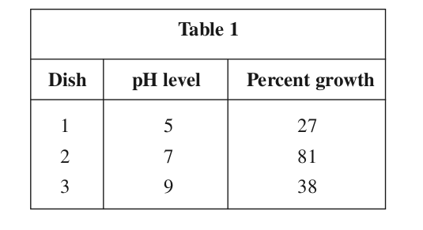
Experiment 2
A known quantity of Salmonella bacteria was placed in each of three petri dishes with different nutrient concentrations in the form of organic compounds. The temperature and pH level were held constant in each sample. The lids of the petri dishes were replaced, and the dishes were left alone. After six hours, the percent growth of Salmonella bacteria was recorded (Table 2).
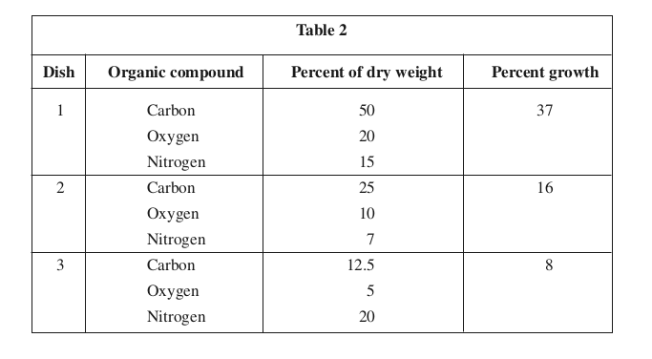
Experiment 3
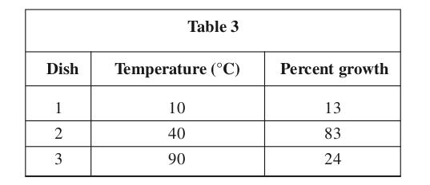
A known quantity of Salmonella bacteria was placed in each of three petri dishes at different temperatures. The pH level and nutrient concentrations were held constant. The lids of the petri dishes were replaced, and the dishes were left alone. After six hours, the percent growth of Salmonella bacteria was recorded in Table 3.
1. According to Table 1, what might best contribute to the growth of Salmonella bacteria?
- A pH level above 9
- A pH level below 5
- A pH level near 7
- A pH level near 5
Solution: The correct answer is C. According to Table 1, Salmonella bacteria had the largest percent growth at a pH level of 7. This information suggests that a pH level near 7 might best contribute to the growth of the bacteria.

2. According to the results of the three experiments, which combination of the three factors studied would be expected to produce the highest percent growth?
- pH level of 5, Organic Compounds in Dish 2, Temperature of 40°C
- pH level of 7, Organic Compounds in Dish 2, Temperature of 10°C
- pH level of 7, Organic Compounds in Dish 1, Temperature of 40°C
- pH level of 9, Organic Compounds in Dish 1, Temperature of 90°C
Solution: The correct answer is C. To answer this question, you must look at the results in all of the tables and choose the conditions that create the highest percent growth of bacteria. In Table 1, a pH level of 7 created the highest percent growth (81%) of the bacteria. In Table 2, the organic compound in Dish 1 created the highest percent growth (37%) of the bacteria. In Table 3, a temperature of 40°C created the highest percent growth (83%) of the bacteria. Combining these three conditions would be expected to produce the highest percent growth.

3. Which of the following conclusions is strengthened by the results of Experiment 1?
- Salmonella bacteria reproduce most efficiently in an acidic environment.
- Salmonella bacteria reproduce most efficiently in a neutral environment.
- Salmonella bacteria cannot reproduce in a basic environment.
- Salmonella bacteria cannot reproduce in an acidic environment.

Solution: The correct answer is B. Table 1 shows that the Salmonella bacteria reproduced most efficiently at a pH of 7 (neutral). A conclusion stating that Salmonella bacteria reproduce most efficiently in a neutral environment would reaffirm the results of Experiment 1.

4. Bacteria will often reproduce until all of the available nutrients have been depleted. How could the experiment be altered to maximize the length of time that bacteria will reproduce?
- Change the observation time from 6 hours to 12 hours.
- Regularly resupply each group of bacteria with unlimited nutrients.
- Increase the rate of growth by decreasing the pH levels.
- Do not test the effect of different nutrient combinations on growth.
Solution: The correct answer is B. To maximize the length of time that bacteria will reproduce, the bacteria must not run out of nutrients. In order to make sure that the nutrients are not depleted, the bacteria groups must be regularly resupplied with unlimited nutrients. Answer choice D can be eliminated because it is irrelevant to the purpose of the question.

5. The nutritional requirements of a bacterium are determined by the makeup of the elements within its cells. According to the experiments, which of the following elements are present in the cells of a Salmonella bacterium?
- Nitrogen and hydrogen
- Bases and vitamins
- Nitrogen and acids
- Carbon and oxygen
Solution: The correct answer is D. According to Table 2, the bacteria grew more efficiently in environments with more carbon and oxygen and less nitrogen. This information suggests that nitrogen is not present in the cells of a Salmonella bacterium. Answer choice B can be eliminated because this information was not tested in any of the experiments.
6. The experiments recorded the percent growth that occurred after a 6-hour period. Bacteria often reproduce at a rate that varies drastically from one stage to the next. The best way to study the different stages of growth would be to record the percent growth:
- after 2 hours only.
- after 4 hours, then again after 6 hours.
- after 8 hours only.
- every 15 minutes for 3 hours.
Solution: The correct answer is D. Because bacteria reproduce at a rate that varies from one stage to the next, testing at 15-minute intervals allows study of the different stages of growth most effectively.

Evaluation of Models, Inferences, and Experimental Results - Which Model? Questions
Evaluation of Models, Inferences, and Experimental Results questions ask students to evaluate various types of models (in the form of theories, hypotheses, laws, etc.) based on information provided in the passage, or on new information provided by the question itself.
These types of questions may reward students who can:
- find basic information in a model.
- identify implications in a model.
- determine which models present or imply certain information.
- determine which hypothesis, prediction, or conclusion is consistent with information presented in the text.
- identify critical assumptions in a model.
- identify similarities and differences between models.
- use new information to make a prediction.
- determine whether new information would strengthen, weaken, or have no impact on a given hypothesis, prediction, or model, and why.
Some Evaluation of Models, Inferences, and Experimental Results questions may be found in passages that provide different "viewpoints" (usually called Hypotheses, Students, Scientists, Theories, or Explanations, or something similar) on an observable scientific event or phenomenon. In passages with this format, there will be similarities and differences between each of the viewpoints. Questions may ask about one, some, all, or none of the viewpoints; the question and the answer choices will indicate which viewpoints, if any, you should consider when searching for the answer.

Go Straight to the Questions
Like other science passage Evaluation of Models, Inferences, and Experimental Results questions will give you plenty of keywords to direct you through the dense language in the viewpoints. Identify these keywords in the questions, find them in the passage, and connect them back to a correct answer choice.
Don't waste time trying to make sense of parts of the passage that aren’t referenced in the questions. Instead, focus on the three other strategies (mark the passage, look for keywords, and focus on similarities and differences) to answer the questions that are being asked.

Look For Keywords
This course has already mentioned how looking for keywords can be helpful on science questions. The same principle applies here: keywords save time and help you reference the passage efficiently. You’ll be able to quickly home in on important words and phrases and find the answer without wasting time sifting through the entire passage. Here’s how the strategy works:
- As you read a question and its answer choices, pick out one or two important words to look for in the passage.
- Keep the word(s) in mind when you return to the passage. Instead of having to reread the whole paragraph, you should be able to go straight to the part that answers the question (do this by scanning for the shape of each keyword, not reading).
Possible Keyword Forms
- names of viewpoints (ex: Hypothesis 1, Scientist 2, Theory 3, Student 4)
- names of variables (ex: temperature, density, velocity, height, distance, angle of trajectory)
- increase or decrease in a variable or multiple variables (ex: volume increases, temperature goes down)
- names of natural phenomena or substances discussed in the passages (ex: acid rain, nimbus clouds, titanium alloy)
- names of natural or scientific processes (ex: subduction, diffusion, condensation, acidosis, classification)

Don’t Be Intimidated By the Vocabulary
The arguments in the passage could contain jargon and sophisticated vocabulary and may refer to complex processes or phenomena. Just remember: you may not need to understand the theories presented to answer the questions. Just go where the questions direct you, and you'll be well on your way to mastering the passage.
Evaluation of Models, Inferences, and Experimental Results questions will likely test your understanding of and ability to compare different viewpoints, rather than your understanding of the science behind them. So keep your focus on identifying the keywords in the questions, scanning for them in the passages, and using them to pick the correct answer choice. Anything outside the scope of the questions is extraneous information.

Rate Your Confidence
HighMediumLowContinue

Evaluation of Models, Inferences, and Experimental Results Example Questions
To review from the previous lesson: Evaluation of Models, Inferences, and Experimental Results questions may test your ability to evaluate more than one alternative hypothesis or theory related to an observable event or phenomenon. Following is an example science passage and several Evaluation of Models, Inferences, and Experimental Results questions.
Directions: Read each passage, then choose the best answer to each question. You may refer to the passages as often as necessary. You are NOT permitted to use a calculator.

Passage I
Remote sensing of the environment is defined as any technique for obtaining information about certain objects through the analysis of data collected by special instruments. These instruments are not in direct physical contact with the objects that are being investigated, and can include photographic cameras, mechanical scanners, and radar systems. Two scientists present their views on different types of remote sensing techniques.
Scientist 1
Remote sensing is best achieved through the use of aerial photographs. These photographs supply researchers with a vast amount of data, which can often be used for additional studies. Large areas can be covered rapidly and at a much lower cost. In fact, it is often possible to share the charges for aerial photography with scientists conducting different research in the same area. Large-scale phenomena can be more easily identified in aerial photographs. In addition, wetlands, rugged terrain, and prohibited areas can be accessed via the air. It is often not necessary to get permission to fly over restricted or hard-to-reach locations.
Scientist 2
The best way to remotely sense the environment is to conduct a ground survey. Measurements are very precise, and field operators become familiar with the physical and cultural features of the landscape. This familiarity allows researchers to gain a deeper understanding of the environment. Minute details can be closely observed and documented. Weather factors that may impede or inhibit aerial photography are generally not a problem during ground surveys. Remote sensors can be strategically placed throughout an area to record data that can be collected at a later date.
1. Is the claim that previously uncharted jungle terrain can best be researched on foot consistent with Scientist 2’s viewpoint?
- No, because aerial photography is best conducted remotely.
- No, because precise measurements are required in ground surveys.
- Yes, because ground surveys yield the most precise data.
- Yes, because wetlands are easily accessible via the air.
Solution: The correct answer is C. Scientist 2 believes that the “best way to remotely sense the environment is to conduct a ground survey.” Ground surveys (conducted at least partially on foot) yield the most precise measurements and allow surveyors to become more intimate with the environment.
2. Scientist 1’s viewpoint contains the basic assumption that:
- remote sensing is the only means to gather important data.
- aerial photographs can be effectively and accurately interpreted.
- ground surveys are the primary remote sensing techniques used today.
- aerial photographs cannot provide adequate information.
Solution: The correct answer is B. Scientist 1 believes that aerial photographs are the best means by which to remotely sense the environment. Therefore, Scientist 1 must believe that aerial photographs can be interpreted effectively and accurately. The other answer choices are not supported by Scientist 1’s viewpoint.
3. Scientist 1 would most likely state that which of the following is an important consideration in deciding upon a remote sensing technique?
- Cost
- Culture
- Climate
- Education
Solution: The correct answer is A. Scientist 1 states that aerial photography can be cost-effective, and that it might be “possible to share the charges for aerial photography with scientists conducting different research in the same area.” This suggests that Scientist 1 is some what concerned about the cost of aerial photography.
4. According to information in Scientist 2’s viewpoint, accurate measurements are possible because:
- large areas can be easily accessed.
- field operators are not familiar with the landscape.
- a vast amount of data can be gathered.
- details can be more easily observed.
Solution: The correct answer is D. Scientist 2 states that in a ground survey, “details can be closely observed and documented.” The other answer choices are not supported by information in Scientist 2’s viewpoint.
5. Both scientists would most likely agree that:
- it is necessary to get permission to remotely sense restricted areas.
- remote sensing of the environment can yield useful data.
- remote sensing is best achieved using photographic instruments.
- it is impossible to identify large-scale phenomena.
Solution: The correct answer is B. While the scientists disagree on which is the best type of remote sensing, they would most likely both agree that remote sensing can be very useful.
6. Scientist 1 would most likely support which of the following statements about remote sensing instruments?
- Strategic placement of remote sensors is critical in gathering useful data.
- Remote sensing instruments cannot tolerate high altitudes.
- Photographic instruments can be modified to capture an entire ground area instantaneously.
- Rugged terrain cannot be remotely sensed with any of the instruments currently in use.
Solution: The correct answer is C. Scientist 1 indicates that aerial photographs are the best method for remotely sensing the environment. Scientist 1 goes on to say that “large areas can be covered rapidly.” This suggests that Scientist 1 would support the idea that photographic instruments can be modified to capture large-scale images.
7. Scientist 2 states that:
- aerial photographs often supply researchers with an excess of data.
- physical and cultural features of the landscape can often be overlooked during a ground survey.
- large-scale phenomena can easily be seen from the air.
- ground surveys can yield highly accurate data, despite potentially bad weather conditions.
Solution: The correct answer is D. Scientist 2 argues that ground surveys are the best means by which to remotely sense the environment, and that weather factors are “generally not a problem during ground surveys.” This best supports answer choice D.

Passage II
Two scientists explain why a study found that moose chose winter sites with more coniferous than deciduous trees. Conifers are trees that do not lose their leaves or needles in the winter.
Late winter bedding sites of moose (Alces alces) were surveyed in February and March of 1995 and were further examined in August of 1995 for the purpose of characterizing and comparing the habitat selected. The data was collected from 102 sampling points in February and 65 in March. Snow depth in February exceeded 50 cm. Snow accumulation in March did not reach this height.
Scientist 1
Coniferous cover is increasingly important in winter during accumulation of snow. Conifer trees do not lose their leaves in winter and provide some cover from snowfall. Moose seek out conifer tree areas for this shallow snow which allows easier movement as well as greater availability of shrubs for browsing (eating).
Scientist 2
If snow accumulation influenced moose habitat, then moose would have sought conifer cover during February and moved out into the open during the reduced snowfalls of March. However, the March sites were characterized by a higher conifer component than were the February sites.
Results consistently indicated that conifer canopy became more significant as winter progressed. So, it was not the snow depth that attracted the moose to the conifers in March, but the crust conditions. While snow depth was reduced in March, the snow crust was softer and impeded moose movement.
8. Which of the following does Scientist 1 suggest draws moose to areas of cover from snowfall?
- Softer snow crust
- Denser forests
- More accessible shrubs
- Deeper snow
Solution: The correct answer is C. Scientist 1 states that moose seek out conifer cover for shallow snow and greater availability of shrubs for eating.
9. According to the passage, which scientist(s), if either, would predict that moose in June would seek conifer cover?
- Scientist 1
- Scientist 2
- Neither Scientist 1 nor Scientist 2
- Both Scientist 1 and Scientist 2
Solution: The correct answer is C. Both Scientists state that moose sought cover because of snow conditions. So in June, when there is no snow, neither scientist would predict that moose would seek conifer cover.
10. Scientist 2 would most likely argue that:
- mobility in the snow is less important than depth of the snow
- depth of snow is less important than mobility in the snow
- conifer cover impedes moose mobility
- deciduous trees provide more food for moose during winter months
Solution: The correct answer is B. At the end of the second paragraph for Scientist 2, he or she argued that crust conditions and not snow depth most affected moose mobility.
11. The views of both scientists are similar because they imply that:
- ease of movement is an important consideration in moose habitat
- moose favor conifer trees to deciduous trees
- snow makeup determines ease of browsing for moose
- moose prefer conifer cover more in February than in March
Solution: The correct answer is A. Both scientists refer to ease of movement. The other choices are either not stated by both scientists or not stated at all. For example, choice B is incorrect because the scientists do not imply that moose always prefer conifers, just that they are useful during winter. And choice D is incorrect because the moose preferred conifer cover in March more than February.
12. The hypothesis of Scientist 2 could best be tested by:
- taking temperature readings in deciduous forests during the next 5 years
- measuring snow depths under conifer cover throughout February and March
- tagging moose and following them throughout the summer
- analyzing data on crust conditions and moose habitats for the past 50 years
Solution: The correct answer is D. Scientist 2’s hypothesis is expressed in the second paragraph, “So, it was not the snow depth that attracted the moose to the conifers in March, but the crust conditions.” Choice D would best test this crust conditions hypothesis. The other choices are interesting but would not directly test the hypothesis.

Passage III
Margarita decides to enter her school's science fair. She has always loved flowers and wants to incorporate them into her project. In the end, Margarita decides to test the effectiveness of different types of plant food (fertilizer) on a certain type of rose bush. Her goal is to determine which fertilizer produces the tallest rose bushes with the greatest number of flowers.
The results of Margarita's experiment are recorded on the graphs below.
Figure 2
13. Which of the following statements is supported by the data in both figures?
- Fertilizer type has little effect on the number of flowers produced.
- Fertilizer helped the plants to grow taller and produce more flowers.
- The control group received more fertilizer than any other group.
- Fertilizer A yielded the tallest plants with the most flowers.
Solution:
Solution: The correct answer is B. The data in both figures shows that plants receiving fertilizer grew taller on average and produced more flowers on average than did the plants in the control group. This supports the statement that the application of fertilizer yields taller plants with more flowers.

Evaluation of Models, Inferences, and Experimental Results - Supporting Theories, Hypotheses, and Inferences
Other Evaluation of Models, Inferences, and Experimental Results questions ask students to consider models in passages where viewpoints are not in direct conflict, but in which data or experimental procedures and results are presented. In these passage formats, the questions themselves may offer additional information regarding the model that requires evaluation based on the presented data or experimental procedure and results.
Again, answering these types of questions will require students to:
- determine which models present or implies certain information.
- determine which hypothesis, prediction, or conclusion is consistent with information presented in the text.
- identify critical assumptions in a model.
- identify similarities and differences between models.
- use new information to make a prediction.
- determine whether new information would strengthen, weaken, or have no impact on a given hypothesis, prediction, or model, and why.
Here's an example question:

Passage I
Margarita decides to enter her school's science fair. She has always loved flowers and wants to incorporate them into her project. In the end, Margarita decides to test the effectiveness of different types of plant food (fertilizer) on a certain type of rose bush. Her goal is to determine which fertilizer produces the tallest rose bushes with the greatest number of flowers.
The results of Margarita's experiment are recorded on the graphs below.
Figure 2
13. Which of the following statements is supported by the data in both figures?
- Fertilizer type has little effect on the number of flowers produced.
- Fertilizer helped the plants to grow taller and produce more flowers.
- The control group received more fertilizer than any other group.
- Fertilizer A yielded the tallest plants with the most flowers.
Solution:
Solution: The correct answer is B. The data in both figures shows that plants receiving fertilizer grew taller on average and produced more flowers on average than did the plants in the control group. This supports the statement that the application of fertilizer yields taller plants with more flowers.

